The National Institute for Mathematical and Biological Synthesis

Biodiversity is __________________________________________________________________

Biodiversity takes into account species richness and evenness:

Species richness is __________________________________________

Species evenness is _________________________________________

What is your HYPOTHESIS? Do you think there will higher biodiversity in the woods or higher diversity in the pasture? Why?

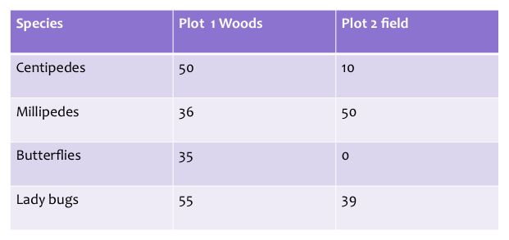

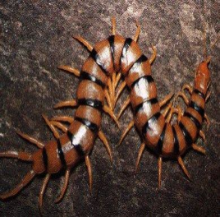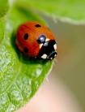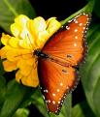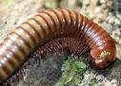

Which plot is more species rich? _____________

Which plot is more species even? _____________

Simpson’s Index:

$D=1-\frac{\sum_{i=1}^{S}{n_{i}(n_{i}-1)}}{N(N-1)}$$D=1-\frac{\sum_{i=1}^{S}{n_{i}(n_{i}-1)}}{N(N-1)}$
DEFINE:

D=

∑=

n_{i}=

N=

S=

Calculate Simpsons Diversity Index for Plot 1 Woods:

Calculate Simpsons Diversity Index for Plot 2 Field:

Which plot is more diverse?

