Addendum to the Report to the UTK Faculty Senate Budget and Planning Committee on

Analysis of Faculty Salary Data based upon Gender

Louis J. Gross, Faculty Senate President and Professor of Ecology and Evolutionary Biology and Mathematics
Bruce A. Johnson, Faculty Senate Graduate Assistant and Graduate Student in Electrical and Computer Engineering
June 28, 2007

This is an Addendum to the report of April 28, 2007. The objective of this Addendum is twofold:
- to provide a revision of the output associated with Resampling Method 2 in the original report, providing a distribution of E* as suggested in the original report; and
- to repeat the analysis for a later data set of faculty salaries, those as of May 2007 which included merit and equity raises given in Spring semester 2007, some of which were intended to address gender equity.

RESAMPLING METHOD 2

The original report provided results on the distribution of E, the statistic arising by calculating the mean difference in salaries within a unit based only on the actual number of gender pairs in that unit. The report noted that it would be useful to compare the distribution of E*, the statistic which would arise by carrying out the Method 2 resampling, keeping the existing salaries for each gender within each unit/rank fixed at the observed values but shuffling them within gender in the manner used to calculate E. The distribution for E* could then be compared to the distribution of E for an additional evaluation of the impact of resampling. We argued that since the mean of the E* distribution will be D*, for large numbers of resamples, we did not expect there to be any different conclusions arising from a comparison of the distributions of E and E*. We here provide the results to compare E and E*, in the process providing an additional visual display of the differences arising from the null hypothesis and that taking account of the actual salary data.

The calculation of E* is essentially identical to that of E except that it utilizes the actual gender salary data for each unit without reassigning all salaries independent of gender. The details are given in the Appendix.

RESULTS OF E* FOR FALL 2006 DATA

Figure 1: Distribution of 4000 resamples for each of the statistics E and E* for which longevity status is considered for the Fall 2006 salary data. The mean of E = 241, the median of E = 253, the standard deviation of E = 609, and the 95% confidence interval for E is (-977, 1432). The mean of E* = 2196, the median of E* = 2195, the standard deviation of E* = 410, and the 95% confidence interval for E* is (1411,3008). Thus the 95% confidence intervals of the distributions of E and E* barely overlap.
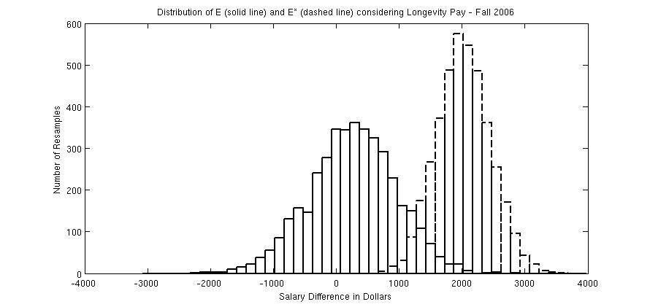

Figure 2: Distribution of 4000 resamples for each of the statistics E and E* for which longevity status is not considered for the Fall 2006 salary data. The mean of E = 307, the median of E = 313, the standard deviation of E = 587, and the 95% confidence interval for E is (-823, 1437). The mean of E* = 1928, the median of E* = 1916, the standard deviation of E* = 411, and the 95% confidence interval for E* is (1151,2784). Thus the 95% confidence intervals of the distributions of E and E* do overlap however the distributions of E and E* clearly differ significantly.

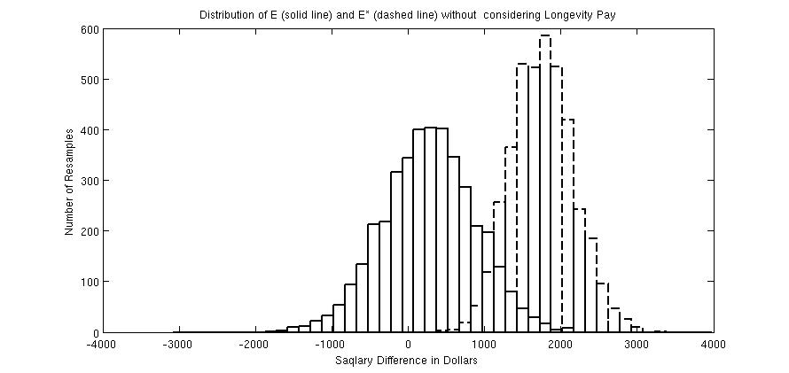

RESULTS FOR MAY 2007 DATA

We include in Table 1 basic descriptive statistics for the 2007 salary data utilized in this study. In comparison to the Fall 2006 salary data, all ranks and genders had increases in mean and median salaries. This is to be expected due to an across-the-board raise which occurred in Spring 2007 in addition to the equity raises. As in the Fall 2006 data, median salaries are lower than means, and mean male salaries are higher than those of females. The salary values in Table 1 are for nine-months and exclude longevity pay.

Table 1. Summary of Faculty Salary Data

Rank | Number in Rank | Mean Salary Males | Mean Salary Females | Median Salary Males | Median Salary Females
Assistant | 355 | 61976 | 55797 | 58902 | 54233
Associate | 347 | 74630 | 67698 | 73430 | 64566
Professor | 482 | 98219 | 85873 | 90802 | 83104

Repeating the analysis in the original report, using the May 2007 data, gives the below figures. These graph the histograms for the distributions of the resampled statistics D and E for both the case in which longevity status is included and the case in which longevity status is ignored, using 4000 bootstrap samples in each case. The calculated value for the statistic using the actual faculty salaries, D*, lies well outside the 95% confidence intervals of D in both cases. Thus the null hypothesis is strongly rejected. The evidence is very strong that the differences in salary between males and females across UTK do not arise from chance assignments of salaries, nor are they explained by differences in gender distributions across units, ranks or longevity status. This still applies to the situation after some equity raises were distributed in Spring 2007.

Figure 3: Distribution of 4000 resamples of statistic D using Method 1 and accounting for longevity. The D* value of 2983 is calculating using the actual faculty salaries.

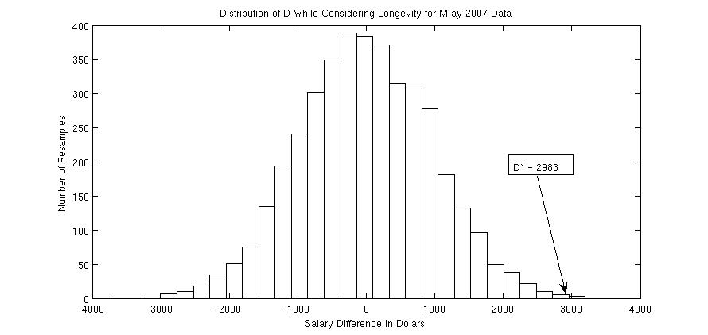

Figure 4: Distribution of 4000 resamples of statistic D using Method 1 without accounting for longevity for the May 2007 data. The D* value of 3378 is calculating using the actual faculty salaries.

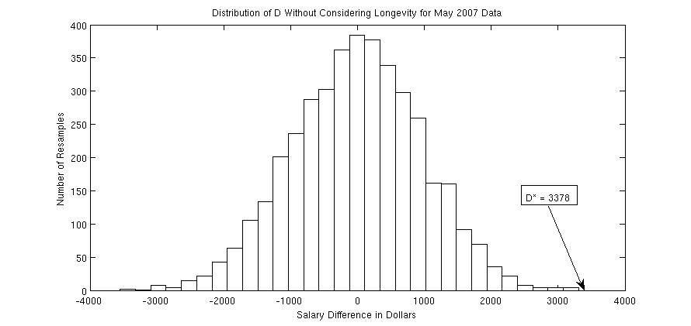

Figure 5: Distribution of 4000 resamples for each of the statistics E and E* for which longevity status is considered for the May 2007 salary data. The mean of E = 268, the median of E = 278, the standard deviation of E = 677, and the 95% confidence interval for E is (-1066, 1559). The mean of E* = 2029, the median of E* = 2021, the standard deviation of E* = 424, and the 95% confidence interval for E* is (1219,2872).

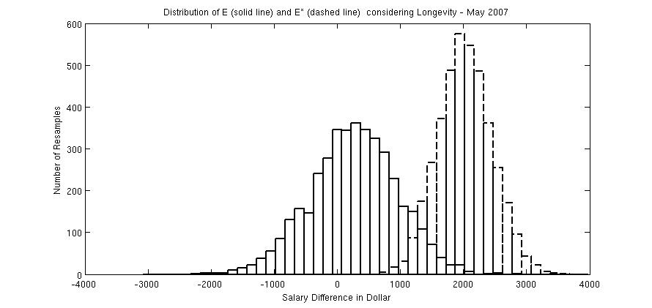

Figure 6: Distribution of 4000 resamples for each of the statistics E and E* for which longevity status is not considered for the May 2007 salary data. The mean of E = 277, the median of E = 280, the standard deviation of E = 599, and the 95% confidence interval for E is (-905, 1430). The mean of E* = 1765, the median of E* = 1758, the standard deviation of E* = 404, and the 95% confidence interval for E* is (1017, 2588). Although the 95% confidence intervals of the distributions of E and E* do overlap, the distributions of E and E* clearly differ significantly.

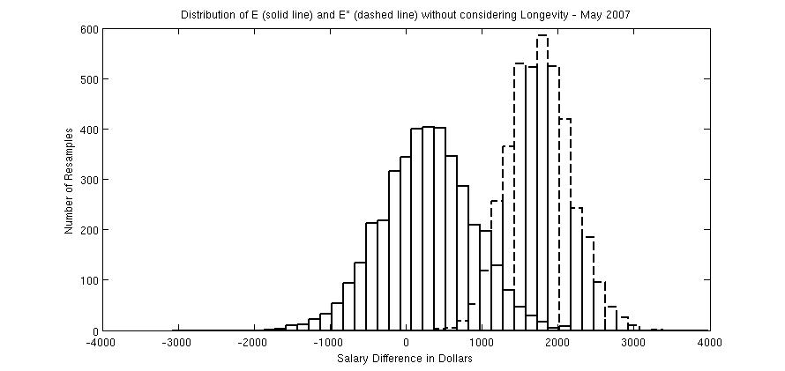

Objective 2 of the original study pointed out that the impact of any modification of faculty salaries can be readily analyzed by carrying out the similar calculations before and after modifications were made to salaries. The analysis above provides an example of this in that we can compare the results of the analysis for the Fall 2006 and May 2007 data. The impact of the salary modifications may be measured simply by comparing the D* values – for the case in longevity is considered, D* decreased by 333 and for the case in which longevity is not considered, D* decreased by 292. Thus, the impact of the salary changes may be interpreted as reducing the level of gender inequity in salary by about $300 or about 10% of the observed differences in salary between genders across campus. Additional evidence for the reduction in differences in salary between genders is obtained by comparing Figures 1 and 5 and Figures 2 and 6 – there is greater overlap in the distributions of E and E* for the May 2007 data than there is for the Fall 2006 data.

Repeating the calculations in the original report to provide a breakdown by unit as to the contribution of each unit to the calculated value of D* gives Tables 2 and 3 below. These provide the magnitude of departmental contributions to D*, from most negative to most positive. The values shown in Table 2 are for the case in which longevity effects within ranks are taken into consideration, while those in Table 3 are the case in which longevity status is not considered. The sum of all departmental contributions in these Tables gives the appropriate D* (for the cases in which longevity is taken into account and that in which it is not). The departmental contributions are negative if average female salary is higher than average male salary (weighted by number of gender pairs) and positive if the reverse is true. The departmental contributions indicate that there are some units that much more greatly contribute to the observed differences in salary across gender than other units.

Table 2: Contributions to the statistic D* arising from each Department, using Method 1 and taking longevity into account. The Department Contributions sum to D* = 2983, the Number of Pairs is the number of gender pairs for each Department, and the Contribution per Gender Pair is the Department Contribution divided by the Number of Pairs.

D* LP = 2983
Department
Number | Contribution | Pairs | Per Pair Contribution
56 | -170 | 7 | -24.2
21 | -101 | 2 | -50.4
58 | -99 | 3 | -32.7
65 | -54 | 9 | -6
11 | -42 | 1 | -41.1
53 | -41 | 7 | -5.7
23 | -40 | 1 | -39.9
35 | -37 | 3 | -12.2
61 | -37 | 3 | -12.1
25 | -32 | 2 | -15.7
15 | -28 | 2 | -13.6
52 | -27 | 2 | -13.4
43 | -24 | 2 | -11.6
55 | -14 | 1 | -13.3
51 | -6 | 2 | -2.9
3 | 0 | 0 | 0
5 | 0 | 0 | 0
7 | 0 | 0 | 0
18 | 0 | 0 | 0
19 | 0 | 0 | 0
20 | 0 | 0 | 0
27 | 0 | 0 | 0
38 | 0 | 0 | 0
44 | 0 | 0 | 0
47 | 0 | 0 | 0
62 | 0 | 0 | 0
6 | 0 | 1 | 0.4
40 | 1 | 3 | 0.4
28 | 1 | 6 | 0.3
37 | 2 | 9 | 0.3
14 | 3 | 1 | 3.2
49 | 3 | 2 | 1.8
31 | 7 | 2 | 4
1 | 11 | 1 | 11.2
42 | 15 | 1 | 15.1
24 | 17 | 8 | 2.2
32 | 26 | 3 | 9
29 | 41 | 1 | 41.1
34 | 43 | 1 | 43.4
30 | 56 | 2 | 28.2
57 | 61 | 9 | 6.8
63 | 66 | 1 | 66.5
41 | 70 | 3 | 23.6
39 | 70 | 13 | 5.4
48 | 83 | 3 | 27.9
50 | 87 | 3 | 29.1
45 | 88 | 3 | 29.4
8 | 94 | 5 | 19
26 | 101 | 12 | 8.5
46 | 102 | 10 | 10.2
36 | 105 | 4 | 26.3
12 | 105 | 3 | 35.1
13 | 105 | 3 | 35.2
17 | 105 | 1 | 105.8
22 | 106 | 3 | 35.7
10 | 110 | 2 | 55.4
9 | 112 | 7 | 16.1
4 | 129 | 1 | 129.8
16 | 156 | 2 | 78.3
33 | 160 | 9 | 17.9
54 | 168 | 2 | 84.2
59 | 175 | 12 | 14.7
60 | 182 | 10 | 18.2
2 | 206 | 4 | 51.6
64 | 213 | 3 | 71.1
66 | 521 | 30 | 17.4

Table 3: Contributions to the statistic D* arising from each Department, using Method 1 without taking longevity into account. The Department Contributions sum to D* = 3378, the Number of Pairs is the number of gender pairs for each Department, and the Contribution per Gender Pair is the Department Contribution divided by the Number of Pairs.

D* No LP = 3378
Department
Number | Contribution | Pairs | Per Pair Contribution
29 | -192 | 2 | -95.8
56 | -152 | 7 | -21.6
58 | -81 | 4 | -20.2
32 | -61 | 4 | -15.2
65 | -57 | 9 | -6.3
21 | -52 | 2 | -25.6
61 | -51 | 4 | -12.6
19 | -43 | 1 | -42.4
53 | -41 | 7 | -5.8
35 | -35 | 3 | -11.3
25 | -34 | 2 | -16.5
15 | -26 | 2 | -12.6
43 | -25 | 2 | -12.1
11 | -15 | 1 | -14.2
49 | -10 | 2 | -4.7
52 | -9 | 2 | -4.3
28 | -4 | 6 | -0.5
51 | -1 | 2 | -0.2
3 | 0 | 0 | 0
5 | 0 | 0 | 0
7 | 0 | 0 | 0
18 | 0 | 0 | 0
20 | 0 | 0 | 0
27 | 0 | 0 | 0
38 | 0 | 0 | 0
44 | 0 | 0 | 0
47 | 0 | 0 | 0
62 | 0 | 0 | 0
23 | 1 | 2 | 0.9
14 | 2 | 1 | 2.9
40 | 7 | 3 | 2.4
1 | 10 | 1 | 10.4
42 | 14 | 1 | 14
31 | 17 | 2 | 8.7
17 | 18 | 2 | 9.2
34 | 28 | 1 | 28.8
63 | 31 | 3 | 10.4
6 | 40 | 2 | 20.1
39 | 42 | 13 | 3.3
24 | 46 | 9 | 5.2
22 | 53 | 3 | 18
37 | 62 | 9 | 7
30 | 71 | 3 | 24
8 | 78 | 5 | 15.8
57 | 82 | 9 | 9.2
4 | 87 | 1 | 87.5
50 | 87 | 3 | 29.3
10 | 91 | 2 | 45.6
26 | 94 | 12 | 7.9
54 | 102 | 3 | 34.1
41 | 110 | 3 | 36.8
55 | 127 | 2 | 63.7
12 | 127 | 3 | 42.6
36 | 131 | 5 | 26.3
16 | 132 | 2 | 66.3
46 | 137 | 11 | 12.5
13 | 156 | 3 | 52.3
9 | 159 | 7 | 22.7
48 | 172 | 4 | 43.1
2 | 191 | 4 | 47.9
64 | 197 | 3 | 66
60 | 213 | 10 | 21.3
59 | 226 | 12 | 18.9
33 | 257 | 10 | 25.7
45 | 401 | 4 | 100.3
66 | 436 | 30 | 14.6

Also shown in Tables 2 and 3 are the number of gender pairs used in the analysis in each department. The number of gender pairs is lower in a few cases when longevity is taken into account, due to the additional subgrouping when longevity is included. As a method to account for the differences in numbers of gender pairs across departments, Tables 2 and 3 provide the contribution to D* per gender pair in the unit. While the contributions of each department to D* vary somewhat when longevity status is taken into account versus when it is not, there is a very consistent grouping of units at both the very positive and the very negative end of the range. This indicates that longevity status does not greatly modify which departments contribute the most to the unequal salary distributions across gender at UTK.

Comparing Tables 2 and 3 in this Addendum to those in the original report shows extremely similar rankings of departmental contributions to the gender differences in salary. This indicates that the raises applied in Spring 2007 made very small changes to the relative contributions of different units to the observed differences in salaries between genders.

Appendix: Calculation of E*

The below details are for the case in which longevity status is included in the analysis. For the case in which longevity is not included, identical methods are employed but ignoring longevity status in each calculation. Including longevity status reduces in general the number of unit/rank groups which are included in the analysis as it is more likely that a particular unit/rank would not have at least one gender pair in the same longevity status.
Definitions:

u represents the unit identifier, u = 1,…,U where U is the number of units (in our case there are 66 units)

r represents the rank identifier, r = 1, 2, 3 for Assistant, Associate and Full Professor respectively

l represents the longevity status identifier, l=1,2 where l=1 corresponds to longevity pay below the average for that u, r and l=2 corresponds to longevity pay above or equal to the average for that u, r

g represents gender identifier, g=1,2 with g=1 denoting male and g=2 denoting female

F(u,r,l) = Number of females in unit u, at rank r, with longevity status l

M(u,r,l) = Number of males in unit u, at rank r, with longevity status l

T(u,r,l) = Total number of faculty in unit u, at rank r, with longevity status l
= F(u,r,l) + M(u,r,l)

N(u,r,l) = Min ( F(u,r,l), M(u,r,l) ) – this is the number of gender pairs in unit u, rank r and longevity status l

S_{i}(u,r,l,g) = Salary (Base, not including longevity pay) of the i^{th} faculty member in unit u, rank r, longevity status l and gender g. Here i = 1,2, …, M(u,r,l) if g=1 and i = 1,2, …, F(u,r,l) if g=2.

Rather than as is done for E, for which all salaries within a unit are shuffled, the salaries within a unit are shuffled only within the gender group with a larger number of members. Thus, if there are 3 females and 8 males of the same rank and longevity status within a unit, then the salaries for the smaller gender group (the females in this case) are all used and a sample of this same number of salaries (3 in this case) is chosen randomly from the larger gender group (8 males in this case). The difference in mean salary is then taken for these data, and normalized by the number of gender pairs. If there are exactly the same number of males and females in this unit/rank/longevity group, then the value obtained is simply the difference in mean salaries between the males and females in that unit/rank/longevity group. These values are summed over all units/ranks/longevity groups, in which each of these is weighted by the number of gender pairs, to obtain one bootstrap sample of the statistic E*. This is then repeated until the desired number of bootstrap samples are obtained.

If M(u,r,l) ≥ F(u,r,l) then randomly shuffle the set of male salaries for this (u,r,l) to create

$$\left\{S_{i}^{j}(u,r,l,1)\right\}\text{for}j=1,\text{.}\text{.}\text{.}\text{.},R\text{and}i=1,\text{.}\text{.}\text{.}\text{.},M(u,r,l)$$

which is simply a random permutation of the male salaries for this (u,r,l), where R is the number of bootstrap samples to be taken. We compute the sum of the subgroup of the assigned male salaries up to the number of gender pairs, as well as the sum of all the female salaries
$$(1){\bar{S}}^{j}(u,r,l,1)=\sum_{i=1}^{N(u,r,l)}{S_{i}^{j}}(u,r,l,1)$$
$$(2){\bar{S}}^{}(u,r,l,2)=\sum_{i=1}^{F(u,r,l)}{S_{i}}(u,r,l,2)$$

where here we note that N(u,r,l) = F(u,r,l). The contribution to the resampled statistic E^{*j} from this unit/rank/longevity is then

$$(3)C^{j}(u,r,l)={\bar{S}}^{j}(u,r,l,1)−{\bar{S}}^{}(u,r,l,2)$$

If the reverse situation applies for a (u,r,l) in which there are more females than males, so that M(u,r,l) < F(u,r,l) then randomly shuffle the set of female salaries for this (u,r,l) to create

$$\left\{S_{i}^{j}(u,r,l,2)\right\}\text{for}j=1,\text{.}\text{.}\text{.}\text{.},R\text{and}i=1,\text{.}\text{.}\text{.}\text{.},F(u,r,l)$$

which is simply a random permutation of the female salaries for this (u,r,l), where R is the number of bootstrap samples to be taken. We compute the sum of the subgroup of the assigned female salaries up to the number of gender pairs, as well as the sum of all the male salaries
$$(4){\bar{S}}^{j}(u,r,l,2)=\sum_{i=1}^{N(u,r,l)}{S_{i}^{j}}(u,r,l,2)$$
$$(5){\bar{S}}^{}(u,r,l,1)=\sum_{i=1}^{M(u,r,l)}{S_{i}}(u,r,l,1)$$
where here we note that N(u,r,l) = M(u,r,l). The contribution to the resampled statistic E^{*j} for this unit/rank/longevity is then

$$(6)C^{j}(u,r,l)={\bar{S}}^{}(u,r,l,1)−{\bar{S}}^{j}(u,r,l,2)$$

Finally the j^{th} bootstrap estimate of E is

$$\left(4\right)E^{j}=\frac{\sum{\sum{\sum{C^{j}(u,r,l)}}}}{\sum{\sum{\sum{N(u,r,l)}}}}$$

This provides a distribution for the statistic E* which we can then compare to the distribution of the statistic E. Numerous possible statistical tests can be applied to compare these two distributions, including a simple t-test to compare the means, non-parameteric tests such as the Wilcoxon Mann-Whitney test, or a Chi-square test to compare the full distributions.

